**DAILY ONLINE ACTIVITIES SUMMARY**

|  |  |  |  |  |  |  |  |  |
| --- | --- | --- | --- | --- | --- | --- | --- | --- |
| **Date:** | **08/06/2020** | | | | | **Name:** | **NAIPUNYA VINOD NAIK** | |
| **Sem & Sec** | **IV SEM & A SECTION** | | | | | **USN:** | **4AL18CS050** | |
| **Online Test Summary** | | | | | | | | |
| **Subject** | | **COMPLEX ANALYSIS, PROBABILITY AND STATISTICAL METHODS** | | | | | | |
| **Max. Marks** | | **30** | | **Score** | | | **08** | |
| **Certification Course Summary** | | | | | | | | |
| **Course** | **1)INTRODUCTION TO PROGRAMMING**  **2)E-COMMERCE 101** | | | | | | | |
| **Certificate Provider** | | | **1)GREAT**  **LEARNING**  **ACADEMY**  **2)IIDE** | | **Duration** | | | **1)5.5 HRS**  **2) 2 HRS** |
| **Coding Challenges** | | | | | | | | |
| **Problem Statement: 1) Write a**  [C Program to Generate All the Set Partitions of n Numbers Beginning from 1 and so on](https://github.com/orgs/alvas-education-foundation/teams/2nd-year/discussions/108).  2) [Write a Java Program to check whether the given matrix is magic square or not](https://github.com/orgs/alvas-education-foundation/teams/2nd-year/discussions/107). | | | | | | | | |
| **Status: EXECUTED** | | | | | | | | |
| **Uploaded the report in Github** | | | | | **YES** | | | |
| **If yes Repository name** | | | | | <https://github.com/naipunya-naik/lockdown-coding/blob/master/C%20CODING/partition_08-06-2020.c>  <https://github.com/naipunya-naik/lockdown-coding/blob/master/JAVA%20CODING/MagicSquare_08-06-2020.java> | | | |
| **Uploaded the report in slack** | | | | | **YES** | | | |

Online Test Details: (Attach the snapshot and briefly write the report for the same).

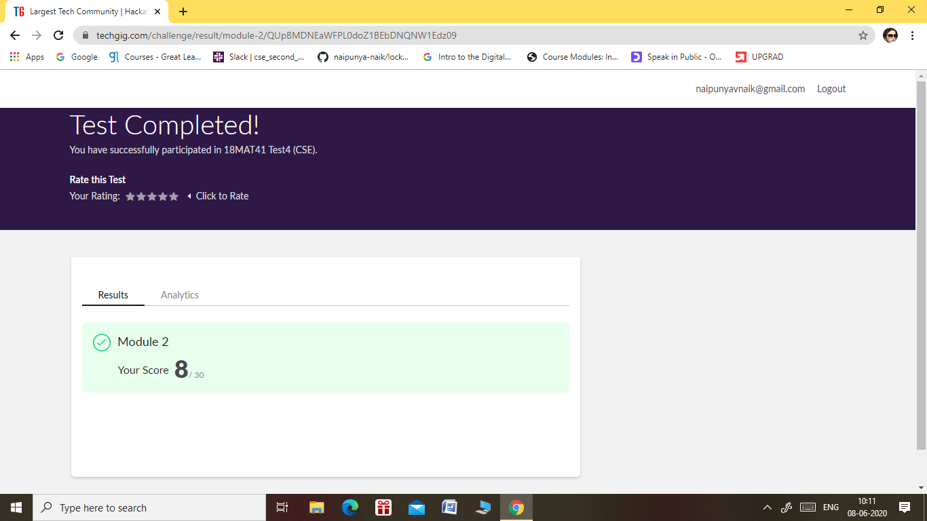

* The 4th I.A TEST OF COMPLEX ANALYSIS, STATISTICAL METHODS AND PROBABILITY WAS CONDUCTED ON 08 JUNE 2020.
* SUBJECT:- COMPLEX ANALYSIS, STATISTICAL METHODS AND PROBABILITY
* SYLLABUS:- MODULE 2
* START TIME:- 9.30 AM
* END TIME:- 10.10 AM
* DURATION:- 40 MIN
* NO.OF QUESTIONS:- 15
* TOTAL MARKS:- 30
* EACH QUESTION CARRIED 2 MARKS

Certification Course Details: (Attach the snapshot and briefly write the report for the same)

CERTIFICATION COURSE NAME:- INTRODUCTION TO PROGRAMMING



**TOPICS LEARNT ON 08 JUNE 2020:-**

* **Variables and Data-types in Python**
* **Intro to Python and Python Basics**
* **Importance and Applications of Programming Languages**
* **Variables in Programming**
* **Decision Making Statements**
* **Looping Statements**
* **Functions in Programming**
* **Object Oriented Programming Concepts**
* **Algorithmic Approach to Solve a Problem**

Coding Challenges Details: (Attach the snapshot and briefly write the report for the same).

PROBLEM STATEMENT 1:- [C Program to Generate All the Set Partitions of n Numbers Beginning from 1 and so on](https://github.com/orgs/alvas-education-foundation/teams/2nd-year/discussions/108).

This algorithm partitions an integer into numbers which sum up to form the original number. It generates partitions of a set of numbers for a given range.

**Sample Input**

Enter a number N to generate all set partition from 1 to N: 5  
Integer partition for 1 is:  
1

Integer partition for 2 is:  
2  
11

Integer partition for 3 is:  
3  
12  
111

Integer partition for 4 is:  
4  
13  
112  
1111  
22

Integer partition for 5 is:  
5  
14  
113  
1112  
11111  
122  
23

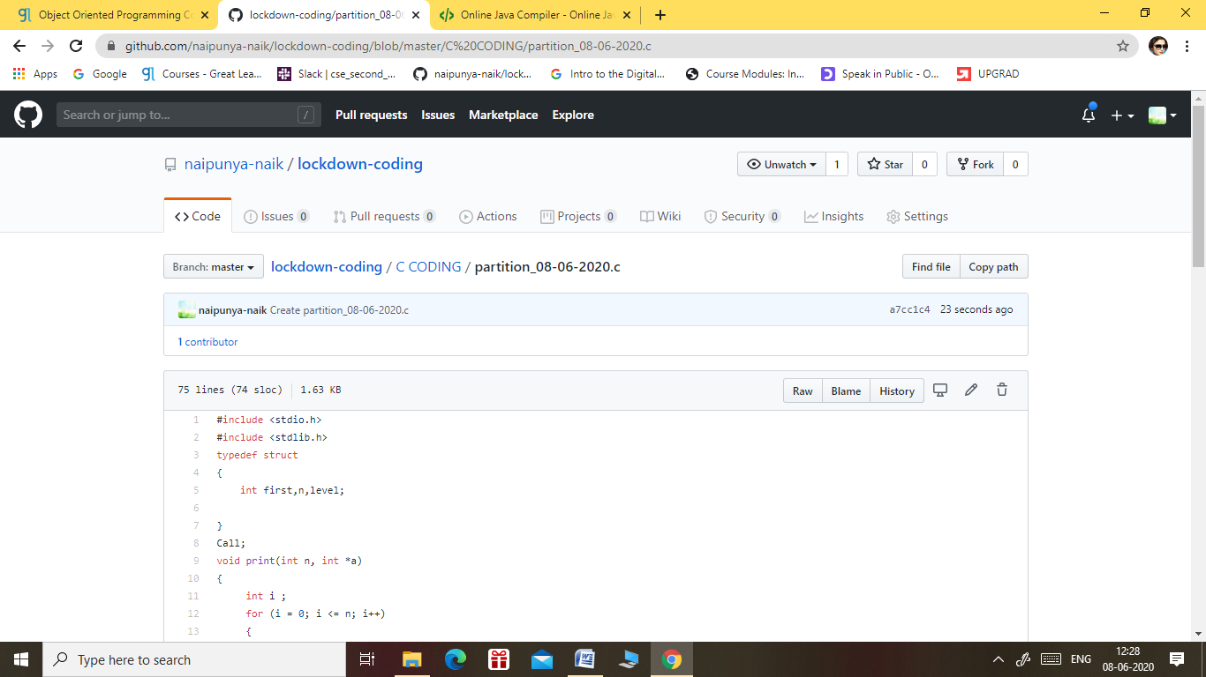

GITHUB REPOSITORY LINK:-

<https://github.com/naipunya-naik/lockdown-coding/blob/master/C%20CODING/partition_08-06-2020.c>

PROBLEM STATEMENT 2:- [Write a Java Program to check whether the given matrix is magic square or not](https://github.com/orgs/alvas-education-foundation/teams/2nd-year/discussions/107)

|  |
| --- |
| Given a matrix, check whether it’s Magic Square or not. A Magic Square is a n x n matrix of distinct element from 1 to n2 where sum of any row, column or diagonal is always equal to same number.  Examples:  Input : n = 3 2 7 6 9 5 1 4 3 8 Output : Magic matrix Explanation: In matrix sum of each row and each column and diagonals sum is same = 15.  Input : n = 3 1 2 2 2 2 1 2 1 2 Output : Not a Magic Matrix Explanation: In matrix sum of each row and each column and diagonals sum is not same. **Step to Follow**   1. Find sum of prime diagonal and secondary diagonal. 2. Calculate sum of each rows and columns. 3. If the prime diagonal and secondary diagonal sums is equal to every row’s sum and every column’s sum, then it is magic matrix. |

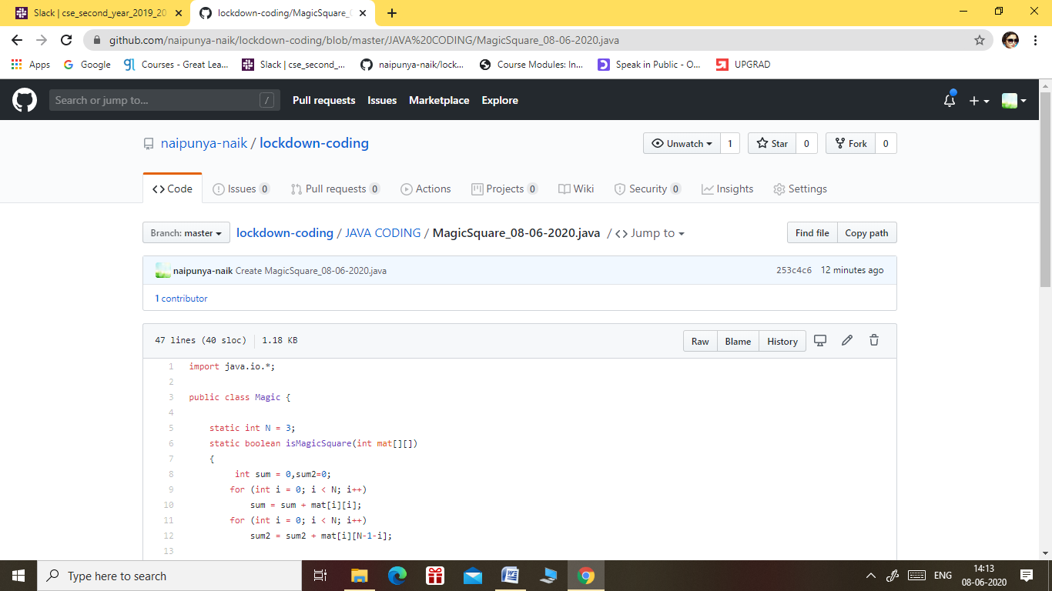

GITHUB REPOSITORY LINK:-

<https://github.com/naipunya-naik/lockdown-coding/blob/master/JAVA%20CODING/MagicSquare_08-06-2020.java>